# Pgadmin4 installtion and configure to postgresql

# 1 . installing pgadmin4

* 1. Add PostgreSQL Repository
* wget --quiet -O - https://www.postgresql.org/media/keys/ACCC4CF8.asc | sudo apt-key add –
* sudo sh -c 'echo "deb http://apt.postgresql.org/pub/repos/apt/ `lsb_release -cs`-pgdg main" >> /etc/apt/sources.list.d/pgdg.list'
  1. Install pgadmin4
* sudo apt update
* sudo apt install pgadmin4 pgadmin4-apache2 -y
  1. Once the installation is complete, open your web browser and type the server IP address
* 10.11.93.175/pgadmin4/
* And you will be shown the pgAdmin4 login page. Log in with your email address and password.

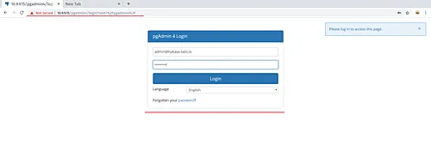

* And you will get the pgAdmin dashboard

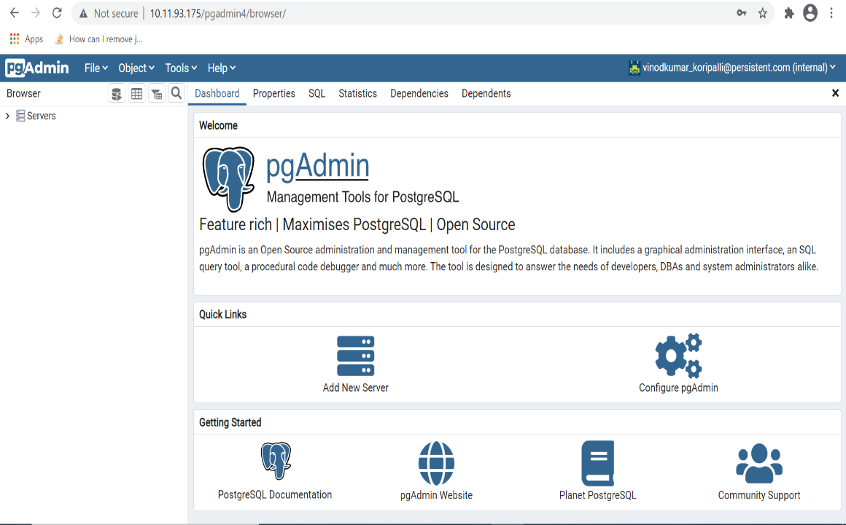

* Now click the 'Add Server' button, type the PostgreSQL Server details that you want to connect.

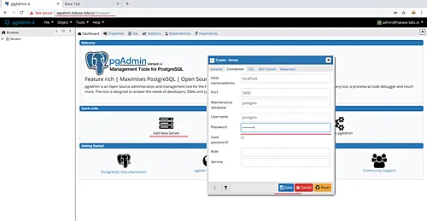

* After that, you will get details about your PostgreSQL database on the left panel side.

